MURA 2019 Annual Business Meeting
Reynolds Alumni Center
March 16, 2019

9:30 a.m. Social time and refreshments

Call to Order and Welcome: The meeting was called to order at 10:00 a.m. by President Jo Turner.

Campus Update: Dr. Latha Ramchand, MU Provost and Executive Vice Chancellor

Jo Turner introduced the first speaker--Dr. Latha Ramchand was appointed Executive Vice Chancellor and Provost at the University of Missouri (MU) in August 2018. Dr. Ramchand came to MU from the University of Houston where she served as dean of the C.T. Bauer College of Business. She began her deanship in 2011, prior to which she served as associate dean for five years, managing programs and administration, budgets and faculty affairs. During her tenure as dean, Bauer College grew enrollment to over 6,400 students, increased retention and graduation rates, raised over $73 million in funds, and established and named three endowed Centers of Excellence.

Dr. Ramchand expressed appreciation and gratitude for the involvement and willingness of MU Retiree’s Association to serve as a connected and supportive partner with MU; she emphasized that the help is definitely needed. Her remarks today were to provide retirees with an update of what is happening at the University in terms of what is exciting and where help is needed. MU is not perfect but is moving in the right direction:

- Match Day was conducted at the School of Medicine on March 15. The results indicate that approximately 25% of those completing students are coming back into residency programs in Missouri. It is significant that individuals trained at the University of Missouri are coming back to use that training to provide services in areas of need to the people of the State of Missouri.

- MU has someone who is trained and spends a lot of time in research, gets recognized at the highest level imagined—the Nobel Prize in Chemistry—and decides to give support to the students in Arts and Science. We’re proud that George Smith and Margie Sable have created a scholarship fund to support students in Arts and Science. Gifts such as this make it possible for more students to attend the University of Missouri and have the experience of being taught by world-class faculty. George Smith is a fabulous researcher, an exceptional teacher and an awesome human being. This gift reflects the commitment and continued support for students who choose to pursue the arts and sciences.

- Research is conducted at the University which creates knowledge that has a huge impact. The knowledge that is produced is taken into the classroom learning environment and is distributed into communities throughout the State. Research dollars have increased about 27% and federally supported research dollars have increased by 7% which is significant. This is a good start but the goal is for research dollars to double by 2020.

- MU not only admits students; but, also adopts the students served. Parents want to be comfortable sending their kids to MU. Admission numbers went up last year about 11% which is good but not enough. The goal for 2020 is to increase by that amount again if not more. MU maintains responsibility for assuring that students graduate on time and move into good paying jobs by providing a good academic learning environment and making learning more customized and user friendly. The retention rate is higher than last year which is good but should be closer to 95%.

- Parents want to be able to afford to send their children to MU. MU is moving in the right direction in that with financial assistance the average costs per year can be decreased from $9700 a year to about $3500. Student support auxiliaries have also made significant changes in helping to reduce the costs. Raising money for scholarships facilitates investing back in our students so the cost of attendance is much lower. With recurring budget cuts over the past three or four years, MU was able to reduce the cost of attendance by 7% rather than passing the cost on to the students.

- Mizzou’s greatest impact is in the benefits to the community. Research and outreach in Education, Social Work and Extension finds its way out to serve others in the state. Research expenditures and Broadband connectivity is being expanded to benefit the citizens of the State.

Retiree Benefits Update: Carol Wilson, Director, Benefits Program, Human Resources

There are no changes in benefits and/or carriers for next year. However, with Medicare Advantage there are three things MU does not control regarding what Medicare funds toward United Health Care (UHC). Carol discussed these items:

Premium Rate Factors
- ACA Insurer Fee
- CMS Funding Methodology
- Annual CMS Funding Call Letter to UHC

A Call Letter has been submitted to UHC which will impact premiums in 2020. The federal ACA Insurer Fee was waived in 2018 but not until late in the year. Thus, we may not know anything about this insurer fee until December 2019. There were changes in the CMS funding method in 2017; now there is scheduled to be less impacts in 2020. Individual beneficiaries such as MURA members can help keep premiums low by taking advantage of annual wellness visits, annual physical checkups, Annual House Call Visits, etc. United Health Care is rated based on utilization. Better utilization of services can result in a better rating which can also mean lower average premiums for all of us.

UHC Medicare Advantage Plan Renewal Process
- There is a three-year rate guarantee from UHC through 2019
- The renewal process begins for 2020
- Next MA bid scheduled for 2021 with an effective date of January 1, 2022

Life/Disability
- RFP process
- Review committee
- Timeline
UM is looking at vendors for life and disability insurance right now and reviewing bids. Vendors will be asked to come in and give presentations (April). We will meet with different committees and groups who will provide input into the process. In June, Board of Curators will approve or disapprove a Life/Disability insurance carrier. Also, Accidental Death and Dismemberment rates and annual enrollment will begin in October.

President Jo Turner encouraged all members to attend the MURA Fall Information Meeting and to monitor the MURA Newsletter for continued updates. Also, retirees can contact the HR Service Center: visit umurl.us/hrsc, call (573) 882-2146 or contact hrservicecenter@umsystem.edu for additional information.

Retiree Pension Fund Update: - Tom Richards, UM Treasurer and Chief Investment Officer (see reports)

There are no huge developments in the status of the pension plan. Tom calls attention to the economics of the stock market--this is the longest Bull Market in history and at some point, will come to an end. The focus at this time is on China. The current economic output of an increasingly interconnected Asian economy, anchored by China, is now comparable to the combined output of the Unites States and Europe. Over the past five years, this Asian economic zone has grown at an annual rate of 6% as compared to just 2.2% in the USA and Europe combined, with the relative disparity in growth rates likely to continue into the future. There is nothing unexpected in terms of performance as this pension plan is one of the best publicly funded plans in the US. The current pension plan funded status: 83% funded; Assets 3,682,638,000; Liabilities 4,413,831,000; Unfunded 731,193,000. There will be no cut to MU Retirees’ benefits checks; the benefit stream is safe and sound.

Secretary’s Report: Leslie Palmer
Jo Turner called for any additions or correction to the Minutes from the March 2018 Annual Business Meeting. Susan Hazelwood moved that the minutes be approved as written; Joseph Headley, seconded. Motion passed. President Turner acknowledge and thanked Secretary Palmer for her two terms of service. She stated that the MURA Board will be honoring Leslie with a gift certificate to be enjoyed at her favorite restaurant.

Treasurer’s Report: Jo Turner for Rob Weagley (see reports)
Attached is the cash flow statement for the 7+ months ended February 21, 2019.
MURA’s cash receipts were less than cash disbursements for the fiscal year by $11,136.74. This deficiency is likely the result of new memberships being below those in Fall 2017, the bi-annual AROHE conference held in the fall of 2018 at a cost of $1,116.66, and the decision by the Board of Directors to match another $10,000 of donation to the Kitty Dickerson Scholarship Fund.
Observations regarding the financial statements:
- Compared to the full year for FY’18, annual memberships for FY’19 are 44% and lifetime memberships are 72% of the total for FY’18
- As the monthly breakfast events are collected online through the Alumni Spaces portal, it is now included as a separate disbursement line on the cash flow statement. The cost to MURA is a 5% transaction fee. This 5% fee covers both the cost to use the Alumni Spaces portal and the credit card transaction fee and the total cost for the first seven+ months is $225.40.
- The Board authorized a contribution of the Association funds to the MURA Scholarship Endowment Fund up to $10,000. This is a matching contribution based on member donations was completed in Fall of 2018 with a final payment of $1848.60. This $10,000 match was resurrected, as of our fall meeting. This obligation has been paid and we are grateful to the philanthropists and bookstore workers in the audience.

Overall, the Association is in satisfactory financial condition, as our checking account has a positive balance. To date, we have not transferred any funds to our investment account, during my tenure as Treasurer, nor have we taken funds from that account other than the dividends that are deposited to the checking account.

Margie Sable moved to accept the Treasure’s Report as submitted; Susan Hazelwood seconded. Motion passed.

Nominating Committee Report and Election: Margie Sable
Margie Sable presented the Slate of Candidates to become MURA Officers and Board Members.

RUTH TOFLE is professor emerita after 34 years in continuous service as chair of the Department of Architectural Studies in the College of Human Environmental Sciences. She has a total of 38 years of employment at MU. “MURA represents and protects the interests of the important MU retiree constituency and the broader MU/UM community,” Ruth says. “I am impressed by its history of promoting the welfare of MU through meaningful programs and the engagement of the over 1,000 members of the organization. I am committed to helping to grow the membership and building upon its history of advocacy and member education. MURA is a critical MU partner and powerhouse making a difference!” Ruth will be active in retirement by maintaining professional activities, being a loyal MU alumna, Rotarian.

MARY LICKLIDER taught junior high and high school students in Webster Groves, Pacific and Columbia, Missouri, during a career of some 22 years that included earning a master’s degree and a doctorate with an emphasis on organizational dynamics. She then created something of a second career at MU where she developed a campus wide network of grant writers over a period of 15 years. Since her retirement from MU, she has been doing grants consulting and spending more time with raising alpacas and making products from their fiber.

ART JAGO is a professor emeritus of management from the Trulaske College of Business. He retired from MU in 2017. He is a former chairperson of the Department of Management and a former member of the Executive Committee of the MU Faculty Council. In retirement he is conducting research on faculty governance in U.S. universities. In 2018, he published articles in Academe, The Chronicle of Higher Education and several op-eds in the Columbia Daily Tribune.

MARY JO HERDE was a full-time administrative staff member in the Asian Affairs Center at MU from 2003 until 2011. She holds degrees from MU in human development and family studies and counseling and educational psychology. Locally, she is the former codirector of Educare Boone County and the Family Counseling Center of Missouri. Since her retirement, she has taught English classes on a part-time basis for visiting Asian government officials and professors at the AAC and college students in China. She and her husband, Al Tacker, keep busy with volunteer activities and travel.

Jo Turner announced that these names have been presented for the ballot for MURA slate of Board officers and members. She asked if there were any nominations from the floor, but none were received. Tom Henderson moved and Doris Littrell seconded that the slate of officers and board members be accepted as presented be elected by acclamation. Motion carried. Congratulations to the candidates.

MURA Membership Survey Report: Art Jago and Committee Members: Kay Barbee, Betsy Garrett, Ina Linville and Dick Otto (See MURA website for full report?)

(Note: this is from January 16 Board Meeting Minutes)
A survey was sent to approximately 1,000 members of the University of Missouri Retirees Association (MURA) in the Fall of 2018. An invitation to participate was sent by email to 732 MURA members. Additionally, an alternative invitation to participate by means of accessing a web address was sent to approximately 185 members who receive their MURA newsletters by US mail rather than email. 313 responses were received for a response rate of 34 percent. Of retirees, 45 percent identified themselves as former faculty; 55 percent as former staff.

Of four organizational objectives, 80 percent of respondents ranked as most important the expectation that MURA will “advocate for the interests/benefits of retirees.” The spokesperson/communication role was ranked second in importance; providing educational/social activities was ranked third in importance.

There was greater member participation in the breakfast series than in other MURA activities, perhaps because the series offers multiple opportunities to attend. Thirty-one percent of respondents reported that they did not participate in any formal MURA activities in the last two years. (It is noteworthy that 10% of respondents reported that they lived more than 100 miles from Columbia.) All formal activities were seen as valuable, with the monthly breakfasts and the annual business meeting perceived as most valuable. Respondents were generous in their suggestions for future breakfast series speakers. With the exception of short one-time lectures/discussions, there was not a demonstrable appetite for additional formal activities in categories specified in the survey. Nonetheless, respondents did make suggestions that would appeal to them individually.

Regarding communication with members, respondents found more value in the newsletters and the email updates than in the MURA website and, especially with older retirees, the Facebook page. Former MU staff found more value in MURA communications than did former faculty members.

Members were generally satisfied with their retirement benefits, particularly their health plans. Recent retirees (i.e., after 2015) were significantly more satisfied with the amount of their pension benefits than earlier retirees (i.e., before 2002).

Conclusions and Recommendations:

- Retiree Benefits. MURA members are satisfied with their health and pension benefits. However, they are also concerned about the lack of cost-of-living adjustments and uncertainty surrounding any future health plan changes. Members count on MURA to be there to advocate for retirees.

- Programming and Communications. Current communications and programs/meetings are well-received by MURA members. Live streaming of events is appreciated by those living a distance from Columbia. Respondents offered specific programming recommendations for the MURA Program Committee.

- Promotion and Education. Most MURA members learned of the organization from existing members. There needs to be more promotion and education about MURA to those who are nearing retirement and those recently retired. Reaching out to new retirees and insuring inclusiveness are important organizational activities.

- Concurrence. With only a few exceptions, retired staff and retired faculty respond similarly to survey questions. MURA goals and activities appeal equally to these primary subgroups of members.

Standing Committee Reports

Awards: Larry Windmoeller
MURA is proud to partner with Chancellor Alexander Cartwright to recruit and nominate candidates for the Retiree of the Year Award. Larry announced that Sandra Taylor will be honored as retired staff member and Jill Raitt as retired faculty member at the Chancellor’s Annual Luncheon on May 21, 2019. Each award includes a plaque and a stipend of $1,000. The May 21 event will also include a resource fair.

Communications: Barb Harris
Three newsletters were created and distributed this year with Maggie Walter and Pat Smith serving as Editors. Distributing the newsletter for those who have an email address did not produce any negative feedback. We only mail about 200 newsletters now instead of the previous 700. The only real recent issue to report is that the Centuryel servers sporadically reject MURA email blasts for no obvious reason which means about 36 folks do not get the emails like everyone else. Social media use is growing. Judy Maseles serves as webmaster and handles online registrations with partner Alumni Spaces. Webmaster Facebook Manager Nancy Johnson reports the following Facebook Analytics: 72 Page Likes (as of March 8th); 1200 people reached in past year; 44 Event Responses; 13 Event Posted in past year.

Education/Breakfasts: – Dick and Anne Hessler
Breakfasts have been well-attended. The most important announcement will be the return to Country Club of Missouri, which has confirmed that they are ready to host the April 2 meeting, and all upcoming breakfast meetings. Scheduled speakers include: April2—Dr. Betsy Garrett will speak about her thoroughly researched and interesting History of Women at UMC’s School of Medicine; May 7—Big Pharma video and presentation organized by Margie Sable; June 4—Dr. Gary Kremer will speak about culmination of years of fundraising and planning which will result in the official opening events in August and September 2019; September 10—Nobel Prize winner, Dr. George Smith will reflect on his recognition and experience in Sweden.

Governmental Affairs: Mary Anne McCollum
MURA is a member of the Flagship Council and supports advocacy for MU through that membership. The September 11, 2018 MURA breakfast meeting featured candidates from the mid-Missouri area running for the five state representative seats on the November 6 ballot as well as the candidates for Boone County Clerk. The format for the Legislative Candidate Forum consisted of each candidate making a response to a question about one of the five constitutional amendments and three propositions appearing on the ballot. State Senator Caleb Rowden also attended the breakfast.
The 2019 General Assembly convened Wednesday, January 9, at noon. Lawmakers kicked off the 100th Legislative session with new leadership in both the House and Senate. For the first time in Missouri’s history, a lawmaker from Springfield, Republican Elijah Haahr, is Speaker of the House. Haahr is an alum of the MU School of Law. Another MU alum, John Wiemann, a state representative from O’Fallon, was elected Speaker Pro Tem. In the Senate, the new majority floor leader, the second-most powerful position in the Senate, is our own Caleb Rowden. Currently serving only his third year as a state senator, he is the first Boone County legislator in half a century to be elected to such a high position of leadership.

From the Boone County delegation, State Representative Sara Walsh was named chair of the Subcommittee on Appropriations – Public Safety, Corrections, Transportation, and Revenue and State Representative Chuck Basye chairs the Committee on Veterans. State Representative Kip Kendrick serves as the ranking minority party member of the House Budget Committee.

The University of Missouri Caucus was officially announced at a news conference at the State Capitol on Thursday, February 21. The informal organization is comprised of state senators and representatives who are alumni of one of the four University of Missouri System universities as well as friends of the University. State Senator Caleb Rowden and State Representative Greg Razer (D-Kansas City and former Truman the Tiger mascot) are leading the newly created caucus.

Kitty Dickerson Scholarship: Gary Smith and Kee Groshong, Marty Townsend Reporting
Eight scholarships have been awarded to date: Nichole Perkins, Luke Currey (2016); Nichole Perkins, Ham Kim, Jeremiah Vick (2017); Nichole Perkins, Han Kim, Emily Scully (2018). Scholarship applications for 2019 are being screened now. Recipients will be honored at the annual Chancellor’s luncheon on May 21, 2019. A history of scholarship recipients will be posted on the MURA website.

Thirty different individuals volunteered for 94.75 hours at the January Mizzou Store event for which the Scholarship fund received $1,421. Fall Mizzou Store volunteer efforts netted $1,848.
In September 2018, the MURA Board approved $10,000 to match individual donations received from July 1, 2018 forward. Eligible donations totaling over $11,000 were received, bringing the Scholarship fund to $71,151. The Committee’s goals is to increase the corpus to $100,000. The Scholarship Committee is working to host a benefit performance by Deke Dickerson this fall, possibly in conjunction with the Roots N Blues N BBZ Festival.

MURA welcomes new gifts to the Scholarship Fund. Donors may go to Mizzou Give Direct to make online gifts at https://tinyurl.com’kittydickersonMURAscholarship. For those who prefer to mail a check, they should indicate the donations is for the Kitty Dickerson MURA Scholarship and send it to:
Mizzou Gift Processing, 407 Reynolds Alumni Center, Columbia, MO 65211

Membership: Dick Otto (see reports)
MURA membership continues to grow.
In 2017 total membership was 822 (727 Life Members and 95 Annual Members. ) In 2018 membership had grown to 862 (774 Life Members and 88 Annual Members.) Current membership as of March 16, 2019 is 922. There are 865 Life Members and 57 with annual memberships. Life Members as a percent of total members has grown from 88.4% in 2017 to 89.8% in 2018 and 93.8% in 2019. Total membership growth was 4.9% from 2017 to 2018 and 7.0% from 2018 to 2019. The two-year growth in membership was 12.2%.

Ombudspersons: Marty Townsend and Bill Fisch
Ombuds Committee co-chairs are nearing completion of an updated “MU Retiree Perks” list, so that retirees and those contemplating retirement can access a directory of commonly requested information such as:
Where to obtain an MU ID MU library privileges
Parking permits Mizzou Store discounts
Educational benefits Gustin Golf Course discounts
International travel insurance Rhynsberger Theater discounts
Mizzou Recreation Complex discounts and more
The list will be presented to the MURA Board at their April meeting and will likely be posted on MURA’s website.

Past Presidents: Jo Turner for Ken Hutchinson
The MURA Past Presidents meet regularly to act as advisors and a sounding board for current MURA officers. In January, they were tasked by MURA President Jo Turner to investigate the matter of cost-of-living-adjustments for University of Missouri retirees. The impetus for the committee’s work was the recent MURA Member Survey. Because MURA does not have an advocacy or policy committee, the Past President’s Committee was charged “to review the MURA survey data, analyze appropriate historical and organizational information, gather additional information, and recommend a course of action for the MURA Board to consider.” A report and recommendations will be presented to the MURA Board for consideration and action at the April 2019 Board Meeting.

Program Committee Report: Betsy Garrett
A calendar of program events for 2019-2020 has been created and shared via newsletters and other channels. It was noted that the Fall Information Meeting is scheduled on a Friday (September 20); further, the Holiday Luncheon is also scheduled on a Friday (December 6). Both events have traditionally been scheduled on a Saturday; the committee reserved the Country Club of Missouri for both events as the Reynolds Alumni Center is no longer available after May 2019. The Spring Social/Ray Schroeder picnic is scheduled for Wednesday, April 17, at Twin Lakes. A “back-up” location at the Community United Methodist Church on West Broadway has been secured in case of inclement weather.

The costs for breakfasts at CCMO will increase from their current charge; therefore, there will be an increase in the cost of the breakfasts beginning September 2019 as well as the Spring Social/Ray Schroeder Picnic next year to $15 per person. The increases are needed in order to cover price increases by vendors and charges for use of the online portal. It was agreed that the fall Information Meeting and the Annual Business Meeting will continue to be free for members.

Retirement/Health/Other Benefits Advisory Committee Report: Kay Barbee
The campus-based committee has been inactive, but efforts have been made to re-engage this group. In the meantime, a subgroup of the MURA Standing Committee along with two of active employees are reviewing the recent MURA survey to assess and summarize the comments. Recommendations will be shared with the MURA Board with the goal of providing input to UM/MU to improve support for current and potential retirees.

University Liaison: Linda Cook
MURA Board Officers meet with Chancellor Cartwright and President Choi two times per year to discuss needs and interests of current and prospective retirees. The Spring meeting date with Chancellor Cartwright has been scheduled for Tuesday, May 7, 2019 at 2 p.m. Further, the Spring Meeting of Four-Campus Retiree Association Leadership Teams will meet at 10:00 a.m. on Thursday, May 9, 2019.

Other Reports (as needed):

New Business (as needed):

Announcements:
- April 13 – MU Campus Open House – The MU Engagement Council is seeking volunteers to help plan and implement MU’s Campus Open House on April 13. MURA’s representative on the MU Engagement Council is Ina Linville, linvilleie@missouri.edu.

- April 25-27 - State Music Festival – The School of Music needs more than 200 volunteers to assist with this on-campus event that welcomes thousands of high school students and guests to Mizzou. To volunteer, complete the online form at the https://goo.gl/forms/RY5cgy1qdhODLGLs2. For further information, contact MURA member Pauli Landhuis at landhuisp@missouri.edu or (573) 529-0916.

Adjourn: The meeting was adjourned at 12:00 noon.

Respectfully,

Leslie J. Palmer
MURA Board Secretary

Minutes to be approved at the Annual Business Meeting Spring 2020

ADDENDUM:

Investment Update
Statement of Cash Flows
Membership Dues

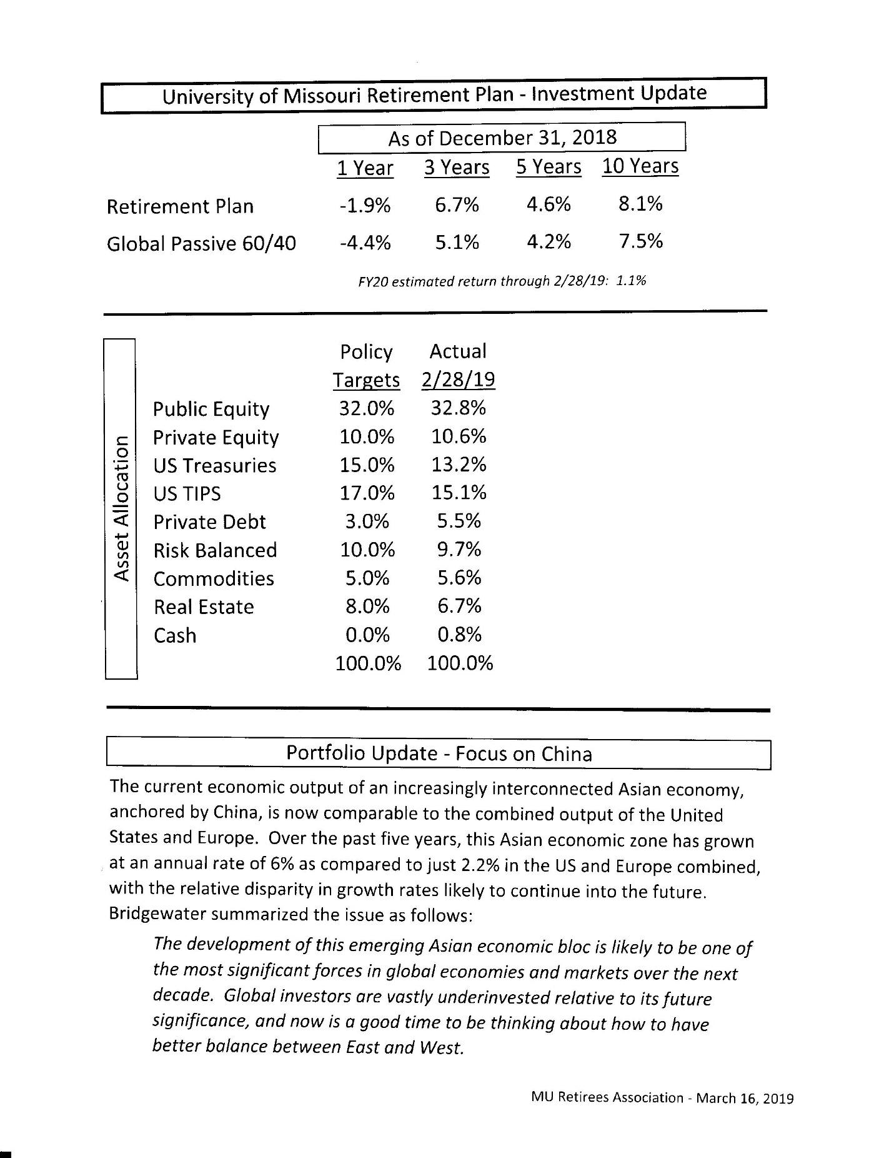

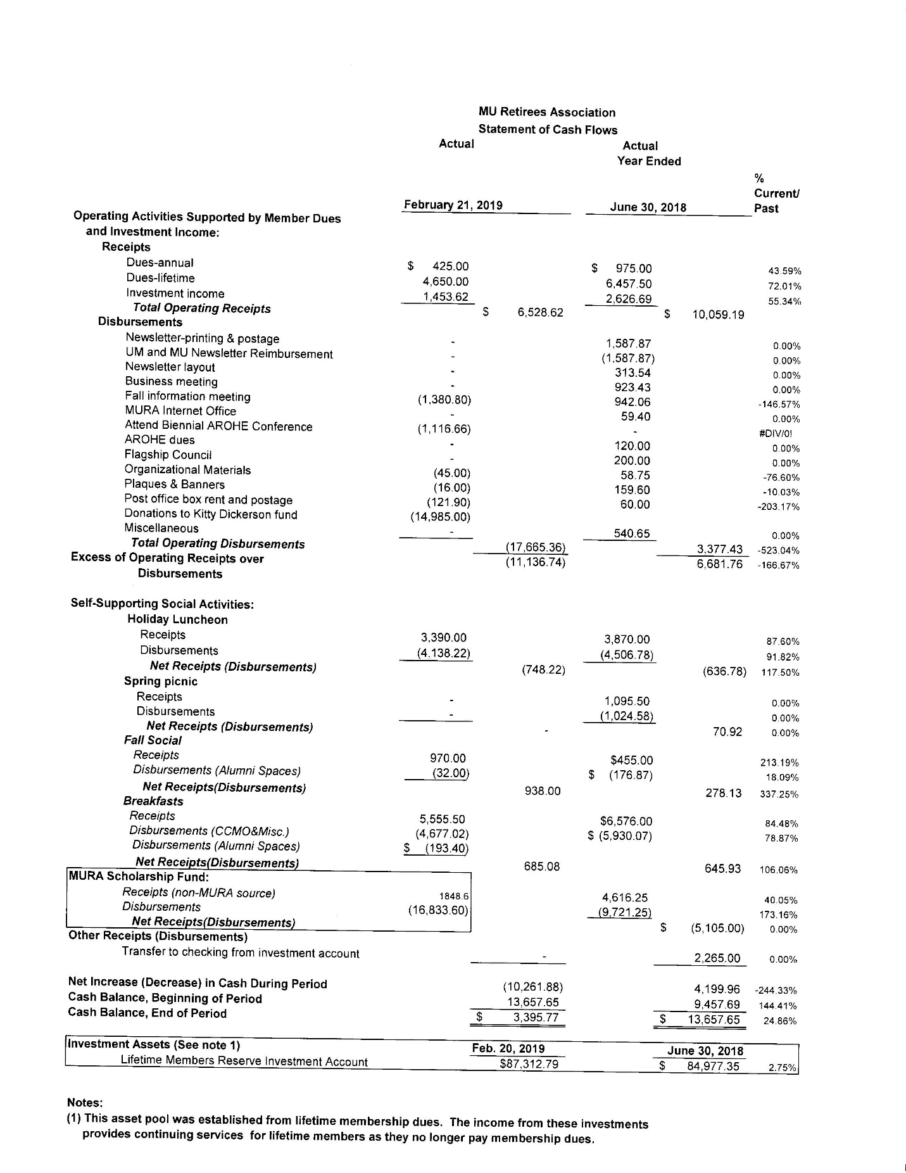

MURA Annual Meeting (March 16, 2019) Membership Dues Report – Dick Otto

Alexander | Hannah | F | 2008 | 2009 | 65203 | MO
Anand | Satish | M | 1998 | 1999 | 29650 | SC
Banks | Alice | F |  | 2017 | 65203 | MO
Banks | Mark | M |  | 2017 | 65203 | MO
Beckett | James | M | 1999 | 2008 | 65201 | MO
Boyer | Harold | M | 1998 | 1999 | 80550 | CO
Brown | Marilyn | F | 2012 | 2015 | 65203 | MO
Buckler | Mildred | F | 2000 | 2001 | 65202 | MO
Butler | Grace | F | 1996 | 1999 | 65202 | MO
Buzzard | Sharon | F | 2017 | 2018 | 65202 | MO
Casati-Zajicek | Jennifer | F |  | 2015 | 65203 | MO
Cassels | Bonnie | F |  |  | 65203 | MO
Coleman | Nancy | F | 2017 |  | 64085 | MO
Dailey | Duane | M |  |  | 65203 | MO
Davis | Diane | F |  |  | 65201 | MO
Dothage | Kathy | F |  |  | 65035 | MO
Dowdy | Carol | F |  | 2004 | 65203 | MO
Dowdy | Richard | M | 2003 | 2003 | 65203 | MO
Duffield | Marlene | F | 2000 | 2001 | 65203 | MO
Edwards | Francine | F | 1997 | 2001 | 65233 | MO
Eggers | Robert | M | 2003 | 2004 | 65010 | MO
Franz | Janice | F | 1987 | 1997 | 65202 | MO
Gayou | Douglas | M | 2015 |  | 65203 | MO
Gelatt | Andree | F | 1995 | 2006 | 65203 | MO
Glenn | John | M | 1992 | 2017 | 65203 | MO
Graham | Olive | F |  | 2014 | 65203 | MO
Hardesty | Mary | F | 2000 | 2004 | 65233 | MO
Hardesty | Murray | M | 2003 | 2003 | 65233 | MO
Headley | Carol | F |  | 2014 | 65203 | MO
Hessler | Anne | F |  | 2006 | 65203 | MO
Hild | Sandra | F | 2013 | 2015 | 65202 | MO
Hill | Robert | M | 2017 |  | 65202 | MO
Hitzhusen | Gerald | M |  | 2018 | 65202 | MO
Holdmeier | Shirley | F | 2017 |  | 65279 | MO
Idle | Linda | F | 2016 |  | 65201 | MO
Ispa | Jean | F |  |  | 65203 | MO
Jackson | Theresa | F | 2016 |  | 65203 | MO
Johnson | Harold | M | 1990 | 1997 | 65201 | MO
Johnson | Lonetta | F |  | 1997 | 65201 | MO
Johnston | Joe | M |  | 2017 | 65203 | MO
Koenig | Sheryl | F | 2017 |  | 65203 | MO
Leonhard | Barbara | F |  | 2018 | 65203 | MO
Maddy | Allen | M | 2017 |  | 65203 | MO
Marston | Christine | F |  |  | 65201 | MO
Martin | Dorothy | F | 2011 | 2012 | 65203 | MO
Mefford | Connie | F | 2017 |  | 65301 | MO
Mefford | Phillip | M |  |  | 65301 | MO
Meyer | Donald | M |  | 2005 | 65203 | MO
Meyer | John | M |  | 2015 | 65203 | MO
Meyer | Margie | F |  | 2015 | 65203 | MO
Meyer | Rosalia | F | 2000 | 2002 | 65203 | MO
Mills | Rilla | M |  | 2016 | 65203 | MO
Mills | Sue | F |  | 2016 | 65203 | MO
Mills-Gray | Susan | F |  | 2017 | 64725 | MO
Moore | Gerri | F |  |  | 65255 | MO
Niemeyer | Margaret | F | 2011 | 2017 | 65201 | MO
OConnell | Elizabeth | F | 2017 |  | 65203 | MO
Pinkerton | Marjorie | F |  | 1999 | 65201 | MO
Pirch | Ruth | F |  |  | 64075 | MO
Price | Donald | M | 2000 | 2001 | 65203 | MO
Ridgeway | Linda | F | 2003 | 2003 | 65201 | MO
Ritchie | Paul | M | 1989 | 1997 | 65203 | MO
Rogers | Betty | F |  | 1997 | 65203 | MO
Rogers | Marlin | M | 1986 | 1997 | 65203 | MO
Schulte | Lynn | F | 2006 | 2016 | 65201 | MO
Slusher | Carol | F | 2000 | 2008 | 65201 | MO
Stegall | Dennis | F |  | 2015 | 65203 | MO
Stewart | Cynthia | F | 1999 | 2000 | 65201 | MO
Stewart | Shirley | F | 1988 | 1997 | 65203 | MO
Turner | Donna | F | 2016 | 2017 | 65202 | MO
Wechsler | Barton | M | 207 |  | 65203 | MO
Wechsler | Louise | F | 2017 |  | 65203 | MO
Whiston | Debby | F | 2015 | 2017 | 63445 | MO
Wiegenstein | Steve | M |  |  | 65202 | MO
Wilson | Judy | F | 2000 | 2001 | 65203 | MO
Wilson | Ronald | M | 2000 | 2001 | 65203 | MO
Yronwode | Peter | M |  | 2018 | 65203 | MO
Zajicek | James | M |  | 2015 | 65203 | MO

Paid TO: 2019 (Count=51)
Paid TO: 2020 (Count=6)
Paid TO: 2099 (Count =865)

Paid through 2018 NOT PAID FOR 2019 78
Members in good standing
Paid through 2019 51 5.5%
Paid through 2020 6 0.7%
Life members 865 93.8%

Total members in good standing 922

