BOARD OF DIRECTORS MEETING MINUTES
January 17, 2018

Members present: Jo Turner, Marty Townsend, Rose Porter, Larry Windmoeller, Nancy Johnson, Dick Otto, Leslie Palmer, Brian Foster, Gary Smith, Ken Hutchinson, Bill Fisch, and Libby Miederhoff

The meeting was called to order by President-Elect Jo Turner at 2:02 p.m. Members present introduced themselves, explained their respective MURA roles and named the coldest place they had ever been.

MINUTES: Leslie Palmer

The minutes of the MURA meeting held on Wednesday, September 20, 2017, were presented. No corrections to the minutes. Motion to approve by Dick Otto; seconded by Larry Windmoeller. Motion passed.

Treasurer's Report: Ken Hutchinson for Debbie Robison (See reports for Cash Flows Statement for the six months ended December 31, 2017.)

MURA’s cash receipts exceeded cash disbursements for the first 6 months of the fiscal year by $2,093.
Observations regarding the financial statements:
- The cost of attending the AROHE Conference occurs every other year and we did not have that cost this year.
- Dues are about $1,900 ahead of last year at this time. $1,600 of this increase is in lifetime memberships.
- MURA will begin to incur charges for online transactions in 2018. These transaction fees will be a new cost to the organization.
- The Holiday luncheon continues to lose money but the amount did decrease from a $1,500 loss to a $600 loss this year.
- A person was hired and paid to layout the fall newsletter this year at a cost of $313. This cost is likely to continue.
Overall, the Association is currently in good financial condition. Debbie believes that the current membership fee is extremely low particularly as new costs are being incurred this year as well as the continued uncertainty of the newsletter reimbursement. Debbie recommends raising the fees to a very reasonable $10 annual rate and $100 for a life membership in order to pay for the above mentioned increased costs; and, to look for new opportunities to serve our members whether that be in the form of additional contributions to the Flagship Council or by providing additional opportunities or resources to our members.
Treasurer's Report (CONTINUED): Ken Hutchinson for Debbie Robison (See reports for Cash Flows Statement for the six months ended December 31, 2017.)

Although the MURA Scholarship Endowment Fund is NOT an asset of our organization but instead of MU, the board did ask for an update on the status of the fund. The endowment balance as of December 18, 2017 was $35,620.
Marty Townsend added that the decreased loss at the Holiday Luncheon was due to a price increase from $25 to $30 per person. Marty suggests that MURA would likely break even at $30 per person if dessert were not included in the meal. The $600 loss is due to the inclusion of a dessert which people do seem to like. Dick Otto motioned that the Treasurer’s Report be approved, Ken Hutchinson seconded; motion passed.

STANDING COMMITTEE REPORTS
Program COMMITTEE: Jo Turner

The MURA Program Committee met on January 10, 2018. A complete list of breakfast meeting speakers and events are scheduled through December 2018, which will be announced via bi-monthly, email blasts. Chancellor Alexander Cartwright has been rescheduled to be the MURA Breakfast Speaker in May, 2018.

The Spring Social is scheduled for April 16 at the home of President Mun Choi at Providence Point. It is expected that the registration fee will be approved as a gift donation for the Kitty Dickerson MURA Scholarship. Marty Townsend moves that there be a $25 registration fee as there was last year to go into the scholarship fun pending approval of the President. Gary Smith seconded the motion. Proposal passed. The Annual Business Meeting is scheduled for March 17. The Chancellor is scheduled to show up and make brief remarks. Marsha Fisher, Interim Chief Human Resources Officer and Associate Vice President, Office of Human Resources, Melinda Adams, Interim Assistant Vice President, Benefits and Tom Richards, Treasurer/Chief Investment Officer, Treasurer’s Office, will also be in attendance.

There will be a change to paying on line with a credit card for MURA events and other activities. Judy Maseles is working with Alumni Spaces to be able to set up the systems for payments to MURA’s account. Members will be able to pay for February for one person or for two and can also pay for all breakfasts at once for one person or two. However, no option for paying intermittently throughout is available. There is a 5% surcharge for the $13 transaction per person to pay for the credit card fee. There is also a paper format to register for one breakfast for one or two people at a time or all breakfasts at the same time with one check.

MEMBERSHIP: Dick Otto (see attached report of members as of 1/15/2018)
I have attached an Excel spreadsheet that reflects total paid membership in MURA as of January 15, 2018. There are 836 members in “good standing” – dues paid for 2018 and beyond. Also included in the report is a listing of the 73 folks that have NOT paid their dues for 2018. Please review this list and do NOT hesitate to contact any of the folks on the list that you would consider a friend and provide them with a “friendly” reminder. They can send their dues to MURA, PO Box 1831, Columbia, MO 65205-1831.
MEMBERSHIP (CONTINUED): Dick Otto (see attached report of members as of 1/15/2018)
The 2016 people who have not paid dues for 2017 will be receiving a message in the near future to inform them that they are being deleted from the database. The 2017 people who have not paid dues for 2018 will be receiving a message informing them that their dues are in arrears. Barb Harris is trying to pull together an email distribution list specifically for those members who need a friendly reminder. Dick will work with Barb in this matter. Gary Smith suggested that in addition to these people receiving reminders that their annual membership is due; they also be apprised of what a lifetime membership would be and how that saves them and us a lot of problems.

Jo Turner reminded everyone that System HR will once a year send an email to all MU retirees who are still in the system getting health care benefits, etc. (approximately 4-5000 people) for the purpose of MURA membership recruitment. A significant number of employees retired at the end of 2017. Ken Hutchinson suggested attaching a marketing piece with a list of membership benefits in addition to a membership form to the email. It was suggested that people on the communications team are in the process of designing a promotional brochure. Rose Porter purposed that this is the time to contact the newly retired employees. Dick Otto proposed that the email needs to suggest that MURA is here to represent the benefit interests of retirees and future retirees in that we are protecting our own interests as well. The email must target the interests and needs of retirees as well as the rest of the valid and important reasons to join.

NOMINATING COMMITTEE REPORT: Marty Townsend
The Nominating Committee consists of five people: the three most recent former MURA presidents (Jim Koller, Tom Henderson and Marty Townsend) and two others appointed by the President, Margie Sable, from the membership at large and/or the Board of Directors (Linda Cook and Larry Windmoeller).
The Committee met 12/5/17 immediately following the MURA Breakfast and 12/16/17 just prior to the Holiday Luncheon. Numerous emails and phone calls were exchanged. Additionally, nominations were solicited, including self-nominations, via MURA’s new Email Blast notification system. The Email Blast solicitation garnered one self-nomination, from a new MURA member who had not yet had an opportunity to become active. The Nominating Committee recommended that the President appoint him to the Program Committee immediately, an appointment that he accepted. The committee deliberations have resulted in the following slate, which was unanimously endorsed for election at the annual Business meeting on March 17:

Betsy Garrett – President Elect & Chair of Program Committee
Rob Weagley – Treasurer
Bill Fisch – Faculty at Large
Nancy Johnson – Staff at Large

A brief biography along with head shot photos of the above candidates was sent to Communication Chair Barb Harris on 1/8/18, to be forwarded to the new MURA Newsletter layout and editing team (Pat Smith and Maggie Walter, respectively) for publication prior to the Business meeting.

Awards COMMITTEE: Larry Windmoeller

The MURA Awards Committee met on Tuesday, January 9th, 2018 at Panera's South for an informal meeting to review the procedures for the Chancellor’s Retiree of the Year Award. A review of the awards 2018 checklist was competed to make sure all is in order. So far so good. Special thanks to Sandra Taylor for the excellent preparation of the checklist. Larry spoke with Mary Maxwell who will send him all nominations by March 1, 2018. The Committee agreed to next meet on Thursday, March
1, 2018. Location to be confirmed. Larry, thanks all for a good meeting last Tuesday.

EX-OFFICIO, AD HOC, AND OTHER SPECIAL COMMITTEE REPORTS

MURA SCHOLARSHIP REPORT: Gary Smith

Three members of the Scholarship Committee are in attendance here at the meeting. Kee Groshong (Co-Chair) is on his way to Australia and New Zealand for a month.
- The first week of the Winter Semester MURA volunteers are working at the Mizzou Store. A list of those who worked and the amount received for their efforts will be published later.
- The committee has a Scholarship brochure in the process; photo copies of what the front and the back will look like were passed around.
- A table-top banner has been designed and is in the process of being produced to attract attention to scholarship donation information. Gary has seen what it looks like but doesn’t have it yet.
- As per the Treasurer’s report on today’s date, the endowment balance of December 18, 2017, is $35,620. Gary is hoping that that with the Spring Social at President Mun Choi’s home, the Mizzou Store effort and the matching money, the endowment balance will increase to close to the $50,000 figure.
- The question was raised regarding when to actually move of the matching dollars and how often to transfer the matching dollars to the scholarship fund. Additionally, what information needs to be included in the request for the transfer to occur? It was again pointed out that the matching dollars pertain only to donations. Thus, fund raising efforts such as the Mizzou Store project are not designated for matching dollars; however, the amount accrued at the Spring Social is considered Gift Credit and is therefore designated for matching. Following Board member consideration and discussion, Gary Smith made a motion to transfer $2256 from the MURA account to the Kitty Dickerson MURA Scholarship in accordance with the action taken in 2017 regarding matching funds contributions. Ken Hutchinson seconded. Dick Otto made a friendly amendment to the motion that the Treasurer be direct to transfer matching funds to the Kitty Dickerson MURA Scholarship the Treasurer can then access the amount. Motion carries.

MURA SCHOLARSHIP REPORT (CONTINUED): Gary Smith

- Further, Gary Smith motioned that the MURA membership be asked to vote on and approve the following amendments to the MURA By-Laws to replace the Scholarship Ad Hoc Committee designation with the more permanent MURA Standing Committee designation:

- Section 8. Standing Committees. Add MURA Scholarship at the end of sentence 1.
- Add Section 8, item m. The MURA Scholarship Committee shall oversee the MURA Kitty Dickerson Scholarship Fund and carry out strategies to secure donations to the fund. The committee shall coordinate with MU on the annual selection, announcement, and recognition of scholarship recipients. The committee shall also identify additional opportunities for new and/or expanded MURA scholarships.

Motion was seconded by Dick Otto. Motion carries and will be presented at the March Annual Business Meeting for a vote by the general membership.

University retiree Benefits: Rose Porter

The concerns expressed by retirees regarding the new vision plan were presented at the January Total Rewards Advisory Committee (TRAC) meeting. Listed concerns were: 1) many retirees missed in their letters from September that a new vision plan was coming for 2018; 2) materials and new card received were of very poor quality (someone threw away envelope thinking this was promotional material only), and 3) the letter to retirees needs to be very specific listing current benefits and cost followed by new benefits for next year with cost. These issues/concerns were well received by the System HR staff.

The TRAC group will meet quarterly face-to-face and the months in-between will be by tele-conference for two hours. This is an effort to keep the committee better informed. Three upcoming projects are being prepared. First is the activity analysis survey. Everyone with a non-faculty title will be asked to complete what functions they do. The survey is still in the design phase and so nothing has gone out yet but is expected to be launched this semester. Secondly, a benefit plan re-design for new employees will be studied in depth. Young workers seem to want other things than the current benefit packages offer. There is NO change to benefits for RETIREES being looked at. It is possible there could be change for current employees. Finally, active faculty and staff will see a new design to help them plan for retirement. This process will be all on-line. But as always there are staff to call and get help.

The committee members of TRAC are happy with all the new people who have been assigned to the system-wide HR staff. They have a great attitude and want to do it right. We should all support them.

faculty council: Leslie Palmer for Don Sievert
Faculty Council joined those urging the Board of Curators to name a residence hall after Lucile Bluford. This the Curators approved at their December meeting.

OTHER BUSINESS

OLD BUSINESS

Dues increase options will need to be voted on at the MURA Annual Business Meeting in March. An announcement regarding an intent to pursue a vote at that meeting will need to be included in the February newsletter. The dues increase discussion was tabled at the September meeting until the January 17, 2018, Board Meeting. Marty Townsend made a motion to increase MURA annual dues from $7.50 per year to $10 and life membership dues from $75 to $100 beginning January 1, 2019.

Debbie Robison, in the January 17, 2018, Treasurer’s Report, notes that she would like to see the MURA fees raised to a very reasonable $10 annual membership and $100 for a life membership for the following reasons:

- Deficit spending on some of our events, for example, Holiday Luncheon.
- Membership benefits the costs of which are going up i.e. certain meetings (Fall Information Meeting and Spring Meeting), database costs, newsletter, third party vender, etc.
- Modest increase will put MU on par with the other campuses in the four-campus system
- MURA has had no dues increase since MURA was formed. Gary Smith remembers a time when annual membership dues increased from $2.50 annually to $5 per year. Dick Otto recalls in place a $50 life membership.
- Beginning in January MURA will be charged for no shows at breakfast meetings.
- Additional funds might allow for another match to the scholarship fund as well as to increase the amount of the scholarships awarded.

Thus, Debbie is interested in seeing the fees raised in order to pay for the above mentioned increased costs and to look for new opportunities to serve MURA members whether that be in the form of additional contributions to the Flagship Council or possibly providing additional opportunities or resources to MURA members. Dick Otto suggested that an increase in annual dues become an incentive to become a life member; Dick further suggests the annual membership be increased to $15.00 per year. Gary Smith agreed it is a good idea to make the annual membership fee more of an incentive to become a life member as well as to come up with a good, solid rationale for the increase. The dues increase will affect the new people and it would be good to consider ways to use MURA funds to serve members in a way that invites new retirees to continue to be a part of the University of Missouri family. New retirees can be reminded that the purpose of the Association is to represent, promote and protect the interests of the retirees as well as to promote the welfare of the University of Missouri. The consensus is that the Association could be doing so much more with strong goals. Jo Turner would like to increase the benefits of membership to the people who do not currently participate in events in the form of webcasts, podcasts, etc. Gary Smith supports this idea in that there are 8-900 dues paying members; yet, it is the same 150 people who actually show up and participate. Jo Turner suggested a round table conversation/discussion to brainstorm other services that might better meet the needs of the members. Marty Townsend suggested an annual social event or a reception for new retirees in order for new retirees to meet MURA members and MURA members can greet new retirees and invite them to become members. Educational activities were mentioned as well as possibly a stipend to attract extra-ordinary breakfast speaker for quality webcast and/or podcast production.

Ken Hutchinson made a friendly amendment to the motion by bringing the annual dues increase to $12.50 or $100 life membership that would be effective for membership year 2019 (January 1). He is also recommending that a marketing piece noting additional benefits and things we want to do to help our members see the value of becoming a member be designed and published in order to help MURA become more of a presence. Gary Smith points to the AROHE report by Marty Townsend as an example of what more MURA could be doing and isn’t doing. Marty suggested that it would be prudent to put her report on the website. The persons making the original motion accepted Ken’s suggestion. Ken Hutchinson seconded the motion before the Board: to increase MURA annual dues from $7.50 per year to $12.50 and life membership dues from $75 to $100 beginning January 1, 2019. Board members voted in favor of raising membership dues to $12.50 annual and $100 for life membership beginning January 1, 2019. Jo Turner will put the information in the February Newsletter for voting at the Annual Business Meeting.

New Business

Jo Turner announced that Barb Harris is planning to step down as communications chair; Barb is one of the few people who knows how to manage the membership database. Barb will finish her term in at the end of June, 2018. Jo is requesting input from MURA Board Members in identifying a replacement to be recruited by President Margie Sable. The role of the communications chair is to coordinate the publication of MURA newsletter, membership distribution list, and other communications functions performed by communications team members: Face Book, website, bi-monthly blasts, volunteer opportunities, etc. In addition, this transition maybe an opportunity for the Board to look at the next generation of databases for maintaining and managing MURA membership. Dick Otto and Barb Harris are the only people who know how to work with the current database. It is likely that the current database met a need when it was created; however, over the last decade a number of tools have be developed that may meet the need in a more user-friendly platform. There are Board members who have volunteered to help move the data to a next generation database (Nancy Johnson and Leslie Palmer). Jo asked for volunteers to become a task force to research and recommend a new management system as well as oversee the transition and to identify a new communications chair. Dick Otto, Chair, Marty Townsend and Nancy Johnson volunteered to serve and to report back at the MURA Board meeting on April 18. The following people were suggested as people experienced in data management or who might know of a recent data management retiree: Dale Wilcox, Brenda Selmon, Bill McFarland and Glenda Moum. A note will be placed in a bi-montly blast requesting assistance from the general members.

Dick Otto announced that congratulations are in order to Gary Smith, long-time Flagship Council supporter and Board member, who was recently awarded the Geyer Award in Jefferson City for his work as Mizzou Supporter. The Flagship Council is a private organization of alumni and friends working together to build and protect our historic (1839) flagship University.

Meeting adjourned at 3:47 PM.

Next meeting of the Board is Wednesday, April, 2018, 2:00-4:00 p.m., 307 B Housh Conference Room, Reynolds Alumni Center.

Respectfully submitted,
Leslie J. Palmer, MURA Secretary

MURA BOARD MEETING

January 17, 2018

Dave Housh Conference Room, Reynolds Alumni Center

AGENDA

Call to Order (Jo Turner)
Secretary's report and approval of minutes (Leslie Palmer)
Treasurer's report (Debbie Robison)
President’s Report (covered by Jo Turner)

Standing Committee Reports
- Program Committee (Jo Turner)
- Education Committee report (Dick & Anne Hessler)
- Membership Update (Dick Otto)
- Communications Committee (Barb Harris)
- Nominating Committee Report (Marty Townsend)
- Awards Committee (Larry Windmoeller)
- Scholarship Committee Report (Gary Smith or Kee Groshong)
- Governmental Affairs Committee (Mary Ann McCollum)
- Audit Report (Libby Miederhoff)
- Retirement Health & Benefits (Rose Porter)
- Faculty Council (Don Sievert)
- Staff Council (Nancy Johnson)
- Other committee reports
Old Business
- Electronic portal for money collection
- Website update
- Dues increase proposal
- MU Engagement Council
- Ombudsman
New Business

Adjourn

<Next MURA Board Meeting: April 18, 2018, 2:00-4:00, 307 B Housh Conference Room, Reynolds>

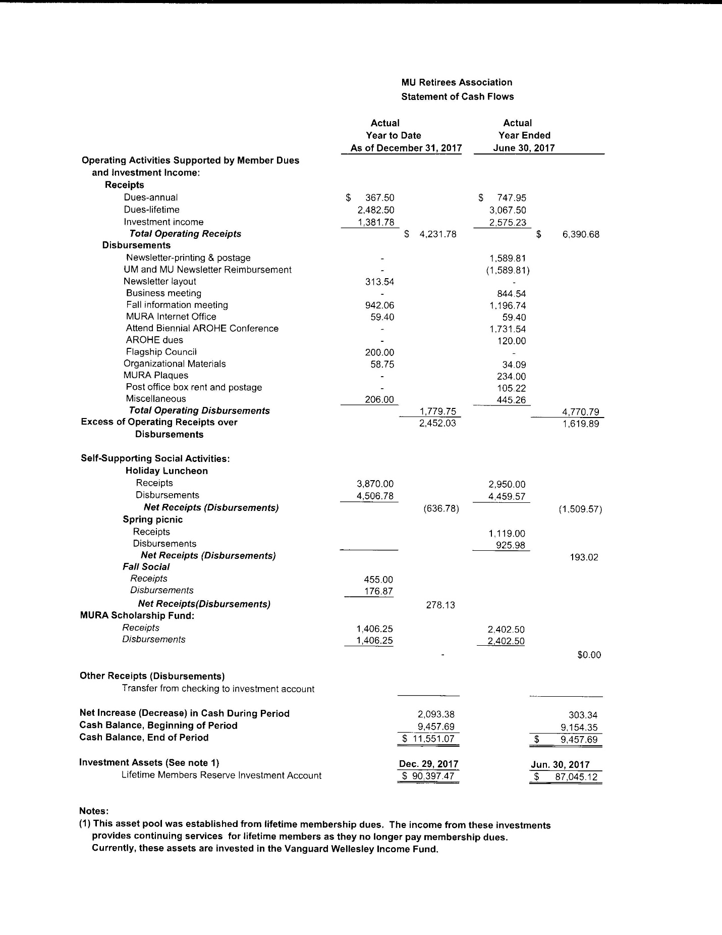
MURA Membership as of January 15, 2018
Paid To: 2016 (Count=62) To be deleted from all MURA correspondence?
Paid To: 2017 (Count=73) Will be contacted prior to any change in the way we interact with
Paid To: 2018 (Count=59)
Paid To: 2019 (Count=5)
Paid To: 2020 (Count=3)
Paid To: 2099 (Count=769)

Total paid members as of January 15, 2018:
Paid to 2018 (Count 59)
Paid to 2019 (Count 5)
Paid to 2020 (Count 3)
LIFE (Count 769

Total paid in Good Standing (Count 836)
Paid to 2017 (Count 73)
Total: 909

Here are the 2017 folks that need to pay for 2018:
Alexander, Hannah Hardesty, Mary Marshall, John Slusher, Carol
Allmart, M Hardesty, Murray Martin, Arlene Thaxter, Jim
Archer, Stephen Harris, Barbara Meyer, Wilbert Turner, Donna
Baxter, Charlotte Hartigan, Mary Miller, Anne Whiston, Debby
Beckett, James Headley, Carol Miller, Max Zajicek, James
Biers, Jane Headley, Joseph Miller, Phyllis
Biers, William Hediger, Marla Mills, Rila
Brown, Gordon Heidlage, Helen Mills, Sue
Bullock, Betty Heidlage, Robert Myers, Myrna
Butler, Grace Holland, Deborah Naeger, Joyce
Christianson, John Holland, Michael Niemeyer, Margaret
Conklin, Kay Honeycutt, Edna Pinkerton, Marjorie
Devaney, Michael Huckaba, Beverly Poehlmann, Linda
Devaney, Susan Johnson, Harold Price, Donald
Dillard, Betty Johnson, Lonetta Queathem, Peggy
Fox, Beverly Knipping, Nancy Rall, Elizabeth
Fox, Roy Kultgen, John Rall, Kenneth
Franz, Janice Land, Norman Ritchie, Paul
Gelatt, Andree Lewis, Marvin Saupe, Joseph
Gelatt, Rod Libbus, Kay Schulte, Lynn
Gentzler, Lynn Luterman, Joan Scott, Gena
Gentzler, Paul Marshall, Carolyn Settergren, Roberta

